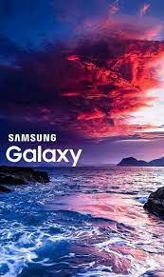

Amit Thorat (12220013)

ISB AMPBA

Advise Samsung on their ‘Galaxy S’ series brand social media strategy.

Table of Contents

**Introduction** 2

**Approach for Social Media Strategy** 2

**Sentiment Analysis** 3

**Topic Identification** 4

**Influencer’s Engagement** 4

**Keywords** **Targeting** 5

**Author Specific Engagement** 5

**Timely & Relevant Post** 7

**Conclusion** 7

## **Introduction**

Samsung is a prominent player in the smart mobile phone industry, having been involved since the inception of smartphones. In the Indian market, Samsung's mobile phones are present across all segments, ranging from affordable devices priced at Rs. 5k to luxury feature phones priced at Rs. 1.5L and beyond. To address diverse market needs, Samsung categorizes its phones into different series such as M series, A series, and Galaxy S series. The M series caters to the low-range smartphone segment, while the Galaxy S series represents feature-rich, top-tier devices equipped with the latest hardware configurations. This assignment aims to capture the dynamic community of Samsung smartphone enthusiasts on Reddit. According to current Reddit data, there are a total of 319K active Samsung fans on the platform who consistently share product reviews, comments, preferences, dislikes, photos, and engage in multifaceted discussions, particularly focusing on the Samsung Galaxy S series posts.

**Reddit Topic**: r/Samsung

**Subtopic**: Galaxy S

## **Approach for Social Media Strategy**

In order to recommend an effective social media strategy for Samsung, the suggested framework encompasses several key steps. This includes conducting sentiment analysis on Reddit posts, identifying trending topics, engaging with influencers, pinpointing keywords utilized by authors and influencers, actively connecting with specific authors, and encouraging them to create timely and relevant posts aligned with the Galaxy S product line.

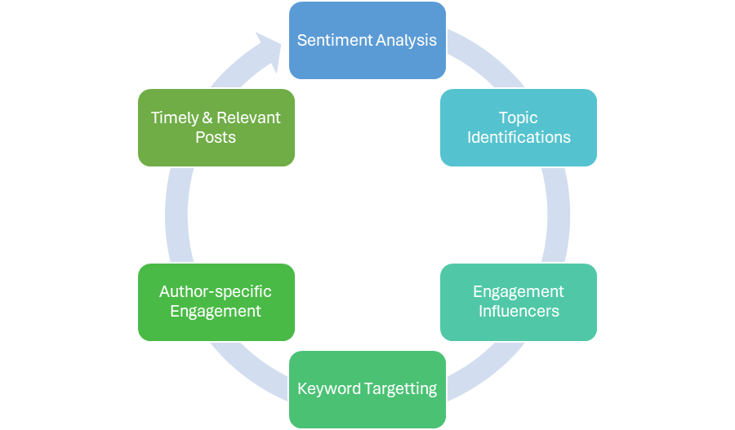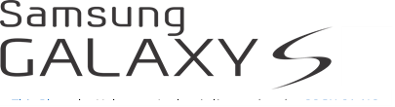

### **Sentiment Analysis**

In my role as a marketing expert, I've undertaken the task of extracting Reddit posts and comments related to the Galaxy S series. By performing sentiment analysis on this data, I aim to unveil a spectrum of emotions and concerns expressed by the community. This nuanced understanding of the community's mindset will serve as valuable insights to formulate the right strategy for Samsung in promoting their Galaxy S series. The extracted data includes information on various aspects gleaned from the posts and comments.

* Post Title,
* Author,
* Total Posts,
* Total Comments,
* Link Karma,
* Comment Karma,
* Score,
* Comment,
* Sentiment, &
* Sentiment Score

Using the score, total posts, & total comments field derived a new field call influence score. Using the influence score identified the top influencers who are posting the regularly for Samsung and Galaxy S series.

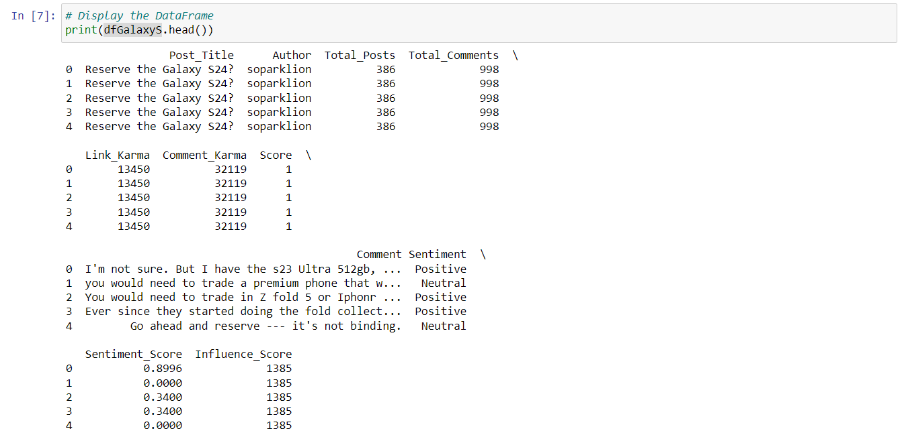

### **Topic Identification**

Analyze the posts, comments and identify the keywords that are highly used in the posts & comments.

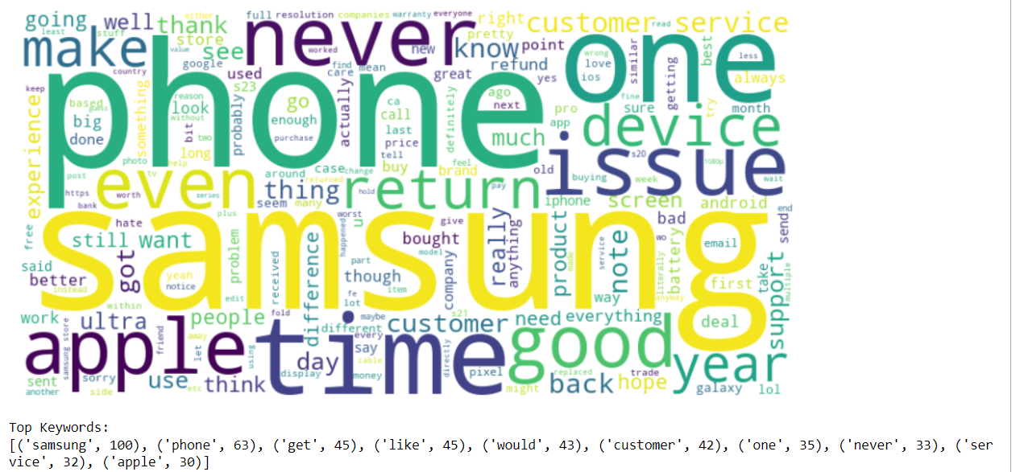

After analyzing the word cloud and the keywords are highly used are ‘samsung’, ‘phone’, ‘one’, ‘service’, ‘customer’, ‘issue, ‘device, ‘return’, ‘time’, ‘apple’ etc. Some of the key topics that Samsung to focus is on combinations of these keywords like ‘***Customer Service’ ‘Service Issues’, ‘Apple’, ‘Phone return’, ‘Phone experience’, ‘Return issue’*** etc.

### **Influencer’s Engagement**

Forge authentic connections with leading influencers within the Galaxy S subreddit. Initiate direct conversations, inquire about their opinions, and demonstrate genuine interest in potential collaborations. Keep a vigilant eye on influencers' posts, actively participating in discussions, thereby enhancing visibility and cultivating a positive relationship.

The top influencers identified from the analysis are:

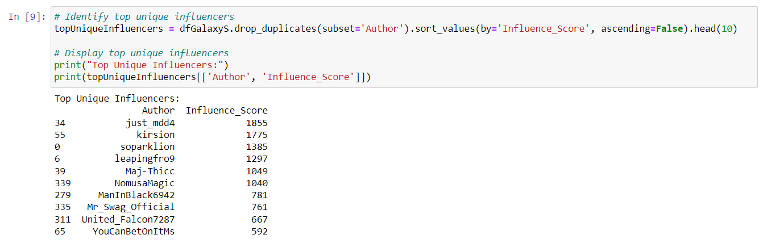

Word cloud made from the influence score of the influencers (author)

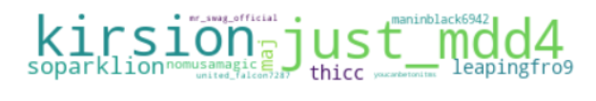

### **Keywords** **Targeting**

Utilizing the keywords identified during the topic identification phase, I conducted sentiment analysis on each keyword, considering its usage context. The findings indicate that many of these keywords positively influence both the posts and comments.

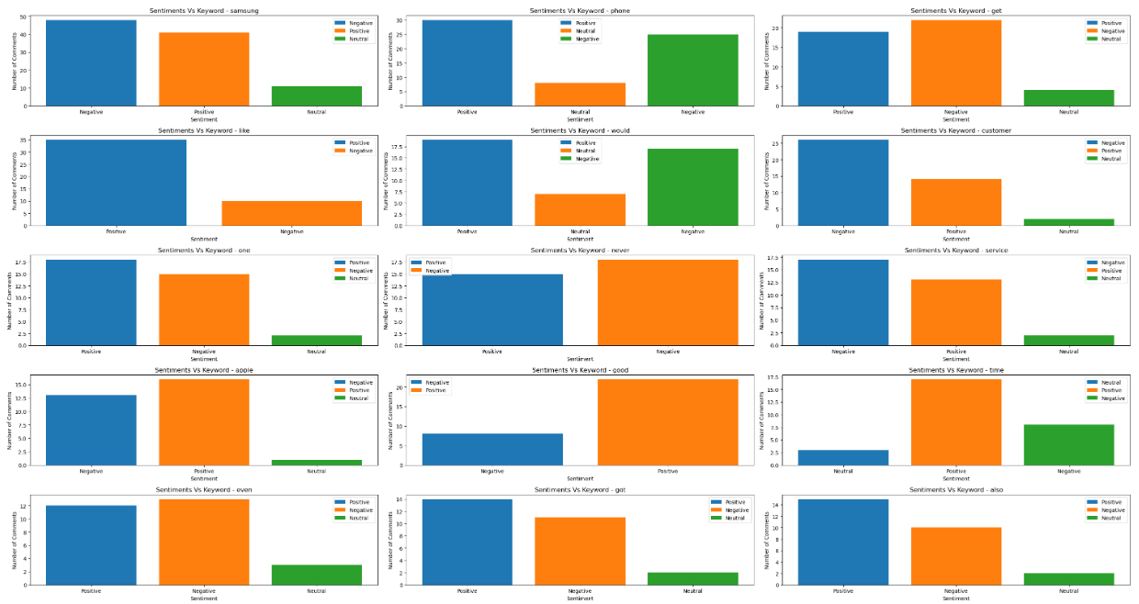

### **Author Specific Engagement**

In this phase, examine the posts and comments of each author, identifying the keywords extensively employed by everyone in their Reddit posts and comments.

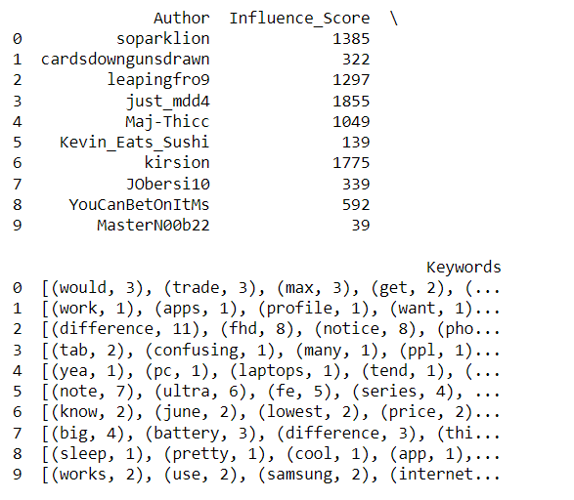

Details of this can be viewed in the attached csv file (aurthor_data.csv)

Word cloud is made for each author based on the keywords that are being used by them in their reddit posts and comments.

|  |  |
| --- | --- |
|  |  |
|  |  |

The images above illustrate the keyword usage of 8 authors. Additional word clouds depicting more authors' keyword usage can be accessed through the Python program.

Leveraging the insights gathered, actively engage with the authors and influencers by acknowledging and appreciating their valuable contributions to Reddit. Recognize the insights they share through their posts and comments. Tailor social media posts to acknowledge these insights, creating personalized content aligned with the preferences of the influencers.

### **Timely & Relevant Post**

Continuously and actively monitor Reddit posts related to the Samsung Galaxy S series, particularly during new launches or product updates. This ongoing monitoring is aimed at gaining insights into current discussions and trends surrounding the product. Share relevant content through Samsung's official channels, focusing on addressing current events, product news, launch events, and company milestones to keep the audience informed and engaged.

## **Conclusion**

In summary, strategically engaging with the top 10 influencers, including *just_mdd4, kirsion, soparklion, leapingfro9, Maj-Thicc, NomusaMagic, ManInBlack6942, Mr_Swag_Official, United_Falcon7287*, and *YouCanBetOnItMs*, presents an opportunity to tap into existing community networks.

Our social media strategy for the Samsung Galaxy S Reddit and subreddit is centered around strategic influencer collaboration, targeted keyword integration, personalized engagement, visual content creation, community feedback incorporation, timely posting, and transparent communication. This approach aims to position the brand as an integral and positively contributing member of the Samsung Galaxy S subreddit community.

By nurturing authentic relationships, collaborating genuinely on content, and transparently sharing information, I propose that Samsung can enhance its brand presence in a manner that aligns with the ethos of the subreddit.